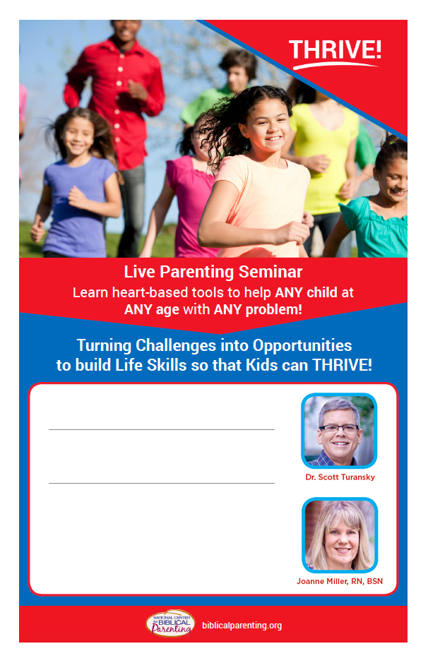

**Saturday, October 20, 2018**

**8:45 am to 1:00 pm  
  
Sponsored by: Forestdale Church  
Held at: Trinity Christian Academy  
979 Mary Dunn Road in Barnstable  
  
  
Cost: $20 per adult/$30 per couple   
(lunch included)  
Bring the whole family!**A children’s program is provided for kids up to age 12.  
  
**For more information or to register visit**

**biblicalparenting.org/register or call 508-419-1768**

**Saturday, October 20, 2018**

**8:45 am to 1:00 pm  
  
Sponsored by: Forestdale Church  
Held at: Trinity Christian Academy  
979 Mary Dunn Road in Barnstable  
  
  
Cost: $20 per adult/$30 per couple   
(lunch included)  
Bring the whole family!**A children’s program is provided for kids up to age 12.  
  
**For more information or to register visit**

**biblicalparenting.org/register or call 508-419-1768**